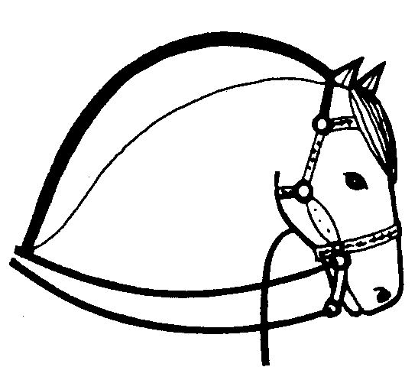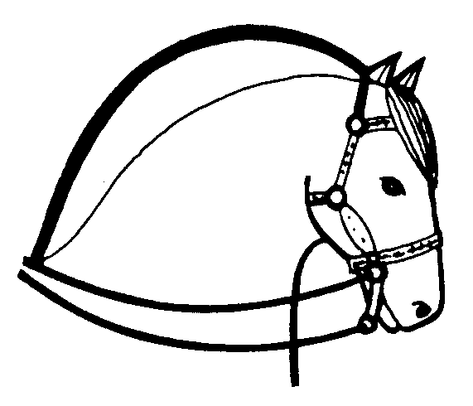 THE FJORD HORSE
NATIONAL STUD BOOK ASSOCIATION

OF

GREAT BRITAIN

SECRETARY

L. Moran CONTACT
Cilyblaidd Manor, e.mail – register@fjord-horse.co.uk
Pencarreg, Tel: - 0044 (0) 1570 480090
Nr Lampeter, Fax: - 0044 (0) 1570 480012

Carmarthenshire, SA40 9QL. GB Mobile - 07702 090906

APPLICATION FOR REGISTRATION OF FJORD HORSE

NAME OF ANIMAL…………………………………………………………………………………………..

SEX…………………………………. ….. DATE OF BIRTH………………………………………

PLACE OF BIRTH……………………………………………………………………………………………..

OTHER REGISTRATION NUMBER(S)……………………………………….

Sire………………………………………………………………… Reg.no……………………………………

Dam……………………………………………………………….. Reg no……………………………………

Previous owner………………………………………………………………………………………………….

When purchased…………………………… Where purchased………………………………………….

Other documents attached (i.e. stallion covering certificate) ……………………………………………….

……………………………………………………………………………………………………………………

I require the above named Fjord/Fjord part bred to be registered with The Fjord Horse National Stud Book Association of Great Britain. I agree for it to be implanted with the Society Approved microchip & DNA typed or bloodtyped if required. The above details are correct to the best of my knowledge and belief.

SIGNED……………………………………………………………………….. DATE………………………….

ADDRESS………………………………………………………………………………………………………….

………………………………………………………………………………………………………………………

Telephone…………………………………. E.mail……………………………………………………………..

THIS APPLICATION FORM MUST BE ACCOMPANIED BY A COPY OF ANY EXISTING PEDIGREE CERTIFICATE, OR DETAILS AS KNOWN TO THE OWNER, PLUS A PHOTOGRAPH AND ANY OTHER IDENTITY DOCUMENTS.

